Date: {{date}}

Saudi Maritime & Logistics Congress 2026

Jeddah Superdome
Kingdom of Saudi Arabia
21-22 October 2026

TO WHOM IT MAY CONCERN,

We hereby confirm that {{company_name}} is exhibiting at the Saudi Maritime & Logistics Congress 2026 exhibition held from 21-22 October 2026 at the Superdome, Jeddah. Their stand number is {{booth}}

Participant Details
Name: {{name}}
Passport number: {{passport}}
Passport Expiry Date: {{exp_date}}
Date of Arrival: {{date_arrival}}
Date of Departure: {{date_departure}}

The preparation of the exhibition will commence on Friday 16 October 2026 and end on the evening of Friday 23 October 2026.
As the organisers of this exhibition, we confirm that the above-named person has registered to attend our event and would like to obtain a Visa to enter the country. We make no suggestions as to the validity of the above information and take no responsibility for the verification of their identity. Further, the company/individual invited will bear all the costs associated with their stay and that of any/all its’ delegation members, including the costs of medical insurance and costs of repatriation.
Informa Markets cannot be held responsible for bearing these or any other costs.

Should you have any queries regarding the event or if I can be any assistance, please do not hesitate to contact us at. SaudiMaritimeCS@Tahaluf.com .

Yours faithfully
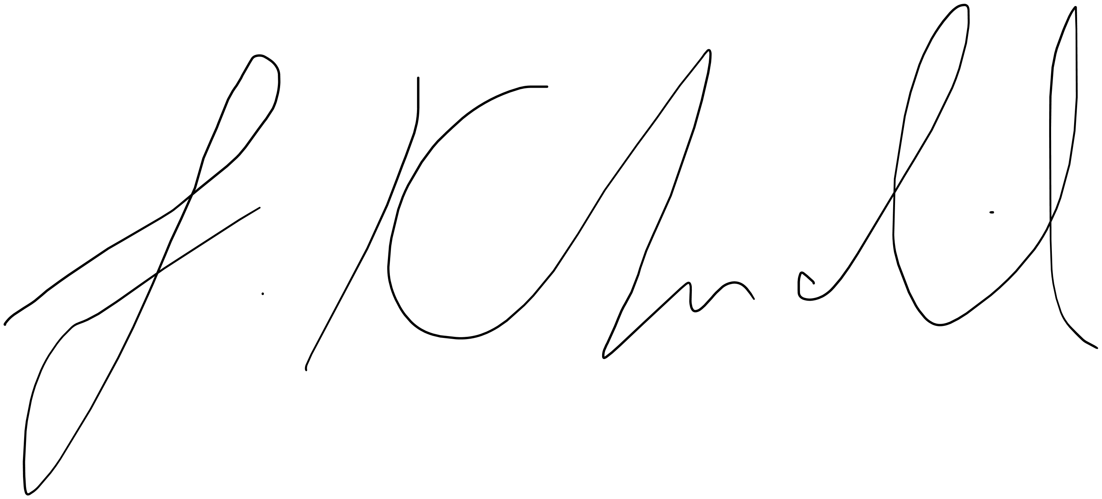
Faariss Khalil
Exhibition Director

